# Importing Existing Java Source Code Into NetBeans IDE 5.5

This document explains how to import existing source code in [NetBeans IDE](http://testwww.netbeans.org/products/ide/index.html) projects. The first scenario outlines the steps necessary to accomplish this when working with standard Java projects, while the second describes the process when working with free-form Java projects (those using an existing Ant script). In both scenarios we'll refer to an imaginary BlackJack example project to illustrate how to set up your application code in NetBeans IDE.

There are two project templates you can use to import your existing Java SE source code:

* [Java Project with Existing Sources](http://testwww.netbeans.org/kb/55/import_j2se.html#with_source#with_source) - Use this project template to create a **standard Java project**. A standard Java project uses the IDE to compile, run, and debug your application.
* [Java Project with Existing Ant Script](http://testwww.netbeans.org/kb/55/import_j2se.html#with_ant#with_ant) - Use this project template to create a **free-form Java project**. A free-form Java project uses your own Ant script to compile, run, and debug your project.

For more information about the different types of project templates, see [Project Types Compared](http://testwww.netbeans.org/kb/55/import_j2se_details.html#templates).

## Getting Your Code Working

Our imaginary BlackJack application consists of three packages: com.jcardshark.blackjack.ui, com.jcardshark.blackjack.lib and resources. For this tutorial, we'll assume that these three packages are located in the BlackJack folder within the JavaGames folder. The screenshot below illustrates our imaginary directory tree. Notice also that the Libraries folder contains a JAR file called jcardshark-core.jar that needs to be on the classpath for the com.jcardshark.blackjack.ui and com.jcardshark.blackjack.lib packages.

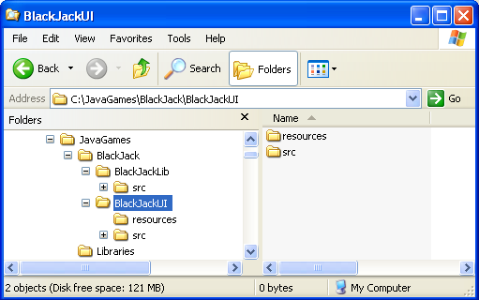

## Using the IDE to Build, Run, and Debug: Standard Projects

To get started, we'll create a main project that will serve as the main entry point for our BlackJackUI application. This project will contain two source roots. Then we'll create a dependent project within which to store our application's required BlackJackLib sources. Next we'll add both the extra library and the BlackJackLib project itself to our BlackJackUI project's classpath. Finally, we'll test our work by running the application.

### Creating a Project with Multiple Source Roots

1. Choose File > New Project (Ctrl-Shift-N).
2. Choose General > Java Project with Existing Sources. Click Next.
3. In the Project Name field, type BlackJackUI. Notice that the IDE automatically suggests this name for the name of the project folder.
   * [More about the main project](http://testwww.netbeans.org/kb/55/import_j2se_details.html#main)
4. Click the Browse button next to the Project Folder field and create a folder somewhere on your system called NetBeans_projects within which to house your NetBeans projects. Then select the newly-created NetBeans_projects folder, ensure the Set as Main Project box is selected, and click Next.
   * [More about the project folder](http://testwww.netbeans.org/kb/55/import_j2se_details.html#folder)

**Note:** The path specified above should appear as follows: NetBeans_projects/BlackJackUI

1. In the Source Packages Folder pane, click Add Folder, navigate to the JavaGames/BlackJack/BlackJackUI folder, and select the resources and src folders.
   * [More about source folders](http://testwww.netbeans.org/kb/55/import_j2se_details.html#source)
2. (Optional) In the Test Packages Folder pane, click Browse to select the folder containing the JUnit package folders. Since our BlackJack project does not contain any JUnit tests, you can skip this step.
3. Click Finish.

The BlackJackUI project is displayed in both the Projects window and the Files window.

* + [More about the Projects window and Files window](http://testwww.netbeans.org/kb/55/import_j2se_details.html#views)

### Creating a Dependent Project

1. Choose File > New Project (Ctrl-Shift-N).
2. Choose General > Java Project with Existing Sources. Click Next.
3. In the Project Name field, type BlackJackLib.
   * [More about the main project](http://testwww.netbeans.org/kb/55/import_j2se_details.html#main)
4. Click the Browse button next to the Project Folder field and navigate to the NetBeans_projects folder you created earlier. Ensure Set as Main Project is not selected and click Next.
   * [More about the project folder](http://testwww.netbeans.org/kb/55/import_j2se_details.html#folder)

**Note:** The path specified above should appear as follows: NetBeans_projects/BlackJackLib

1. In the Source Packages Folder pane, click Add Folder, navigate to the JavaGames/BlackJack/BlackJackLib directory and select the src folder.
   * [More about source folders](http://testwww.netbeans.org/kb/55/import_j2se_details.html#source)
2. Click Finish.

The new BlackJackLib project is displayed alongside the BlackJackUI project in both the Projects window and the Files window as illustrated below.

* + [More about the Projects window and Files window](http://testwww.netbeans.org/kb/55/import_j2se_details.html#views)

### Managing the Project Classpath

At this point we need to add the additional library located in the /JavaGames/Libraries/ folder to both the BlackJackLib dependent project and the main BlackJackUI project.

1. In the Projects window, right-click the Libraries node for the BlackJackLib project and choose Add JAR/Folder.
2. Select JavaGames/Libraries/jcardshark-core.jar, and click Open. The JAR file is added to the project's classpath.
3. Repeat steps 1-2 to add JavaGames/Libraries/jcardshark-core.jar to the BlackJackUI project's classpath.

Now let's add the BlackJackLib project itself to our BlackJackUI project's classpath.

1. Right-click the Libraries node for the BlackJackUI project and choose Add Project.
2. Navigate to the NetBeans_projects folder and select the BlackJackLib project folder. The project should now look as illustrated below.
   * [More about setting the classpath](http://testwww.netbeans.org/kb/55/import_j2se_details.html#classpath)

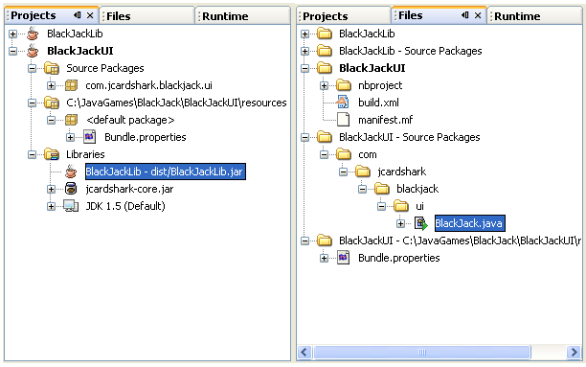

### Running the Application

1. Choose Run > Run Main Project to run the application.
2. In the dialog that appears, set BlackJack.java as the main class.

## Using Your Own Ant Script to Compile, Run, and Debug: Free-Form Projects

If you already have your own build.xml file, you can create a free-form project for your application. In free-form projects you have to manually link any Ant targets you need to the appropriate IDE commands and set up the project's source folders in order to build, run and debug your project. Let's take a look at using a free-form project with an existing Ant script for our BlackJack application.

Just as in the earlier example, we first need to create the project that will house our application and required sources. Next we'll map the Ant targets that will enable us to call IDE commands on our application and configure our project's classpath by adding the necessary sources and specifying the source level for our application. Finally, we'll test our application by building and running the project.

### Creating a Free-Form Project

1. Choose File > New Project (Ctrl-Shift-N).
2. Select General > Java Project with Existing Ant Script. Click Next.
3. On the Name and Location page of the wizard, click the Browse button next to the Location field and select the JavaGames/BlackJack folder. Notice that the IDE automatically suggests this folder as the location of the new project folder. Since the Location folder also contains the project's build script, the IDE automatically picks up the build script location.
   * [More about project location](http://testwww.netbeans.org/kb/55/import_j2se_details.html#folder)
4. Enter BlackJack in the Project Name field, ensure the Set as Main Project checkbox is selected, and click Next.

### Linking Ant targets with IDE commands

1. On the Build and Run Actions page of the wizard, specify which targets the IDE should run for project commands.   
   **Note:** Leave Generate Javadoc and Test Project empty, since the Ant script does not contain targets for these commands. These commands will not be available in the IDE until you write targets for them.
   * [More about linking commands to Ant targets](http://testwww.netbeans.org/kb/55/import_j2se_details.html#targets)
2. Once you have filled in the other target fields, click Next.

### Configuring Source Folders

1. On the Source Package Folders page of the wizard, click Add Folder, navigate to the /JavaGames/ folder, and add the BlackJackLib/src, BlackJackUI/src, and BlackJackUI/resources folders to the project.
   * [More about source folders](http://testwww.netbeans.org/kb/55/import_j2se_details.html#source)
2. In the Source Level combo box, choose the JDK version that you want to compile and run your application against. Click Next.
3. On the Java Sources Classpath page of the wizard, select /BlackJackLib/src in the Source Package Folder combo box. Then click Add JAR/Folder to add jcardshark-core.jar to the source folder's classpath.
4. Select /BlackJackUI/src in the Source Package Folder combo box and then add BlackJackUI/resources, BlackJackLib/src, and jcardshark-core.jar to the source folder's classpath.  
   **Note:** This classpath is not used for compilation or execution - your Ant script handles the classpath for these tasks. These settings only tell the IDE which classes to include in code completion and refactoring.
   * [More about setting the classpath](http://testwww.netbeans.org/kb/55/import_j2se_details.html#classpath)
5. Click Finish.

The BlackJackUI project is displayed in both the Projects window and the Files window as illustrated below.

* + [More about project views](http://testwww.netbeans.org/kb/55/import_j2se_details.html#views)

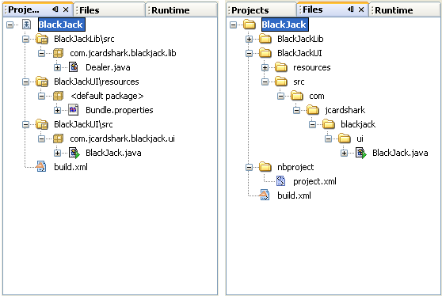

### Running the Program

* Choose Run > Run Main Project to run the application.

**Note:** Your project's Ant script must have a target for running the application.

[*Send Us Your Feedback*](http://testwww.netbeans.org/about/contact_form.html?to=3&subject=Feedback:%20Importing%20Existing%20Java%20Source%20Code%20Into%20NetBeans%20IDE%205.5)

## Next Steps

For more information about using NetBeans IDE 5.5, see the following resources:

* [Introduction to Developing General Java Applications](http://testwww.netbeans.org/kb/55/javase-intro.html)
* [Using NetBeans IDE](http://testwww.netbeans.org/kb/55/using-netbeans/index.html)
* [NetBeans IDE Support and Docs page](http://testwww.netbeans.org/kb/55/index.html)